Project Development Phase
Model Performance Test

Date | 03 October 2026
Team ID | SWTID-2026-5003
Project Name | Implement Client Script and UI Policy (Incident)
Maximum Marks | Not specified

Model Performance Testing:
Prepared for the project team. The report uses available configuration screenshots; no formal performance measurements or signed test results were supplied. Team: Kaleeswari G (Team Leader: Milestones 4 and 5, Milestone 6 Activity 1); Devibala. A. S (Milestones 1 to 3); Karthika. M (Milestone 6 Activities 2 to 4); Amirtha Varshini S (Milestone 6 Activity 5 and conclusion).
S.No. | Parameter | Values | Screenshot
1. | Model Summary | Not applicable: the project runs on ServiceNow Incident and does not configure Salesforce objects, fields, or reports. | 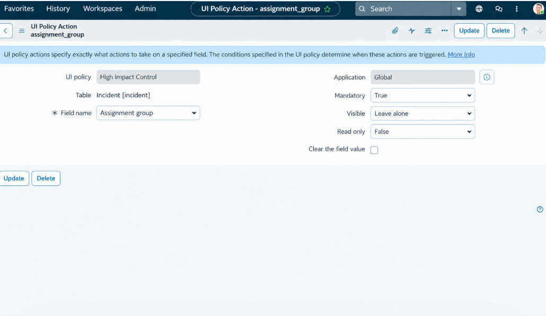
2. | Accuracy | No AI/model accuracy score is available. Screenshot evidence documents configuration and selected form behavior only. | 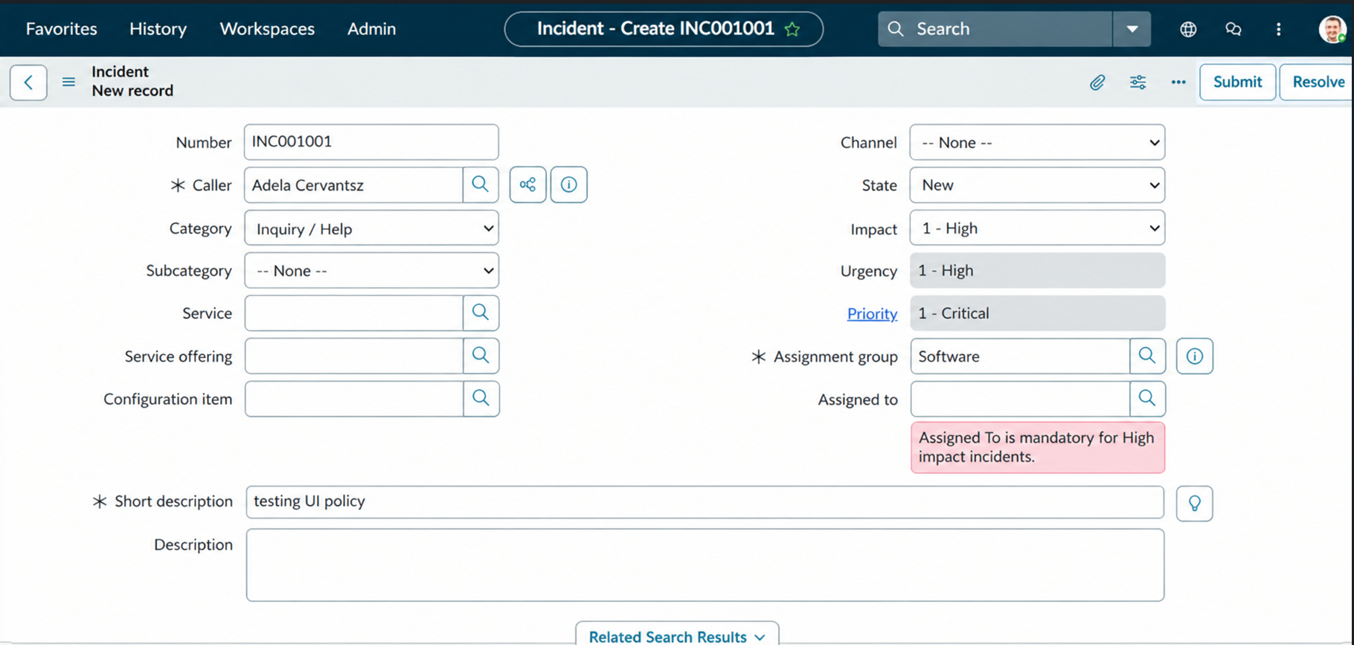
3. | Confidence Score (Only Yolo Projects) | Not applicable: no YOLO model, object detection, or confidence score is used. | 